BANK CRM
(Customer Relationship Management)
Project Done By
JAYESH MALI
Objective Questions:
- What is the distribution of account balances across different regions?
SQL Query:
select ci.GeographyID ,
sum(b.balance) as distribution_balance
from bank_churn b
join customerinfo ci on b.CustomerID = ci.CustomerID
group by ci.GeographyID;
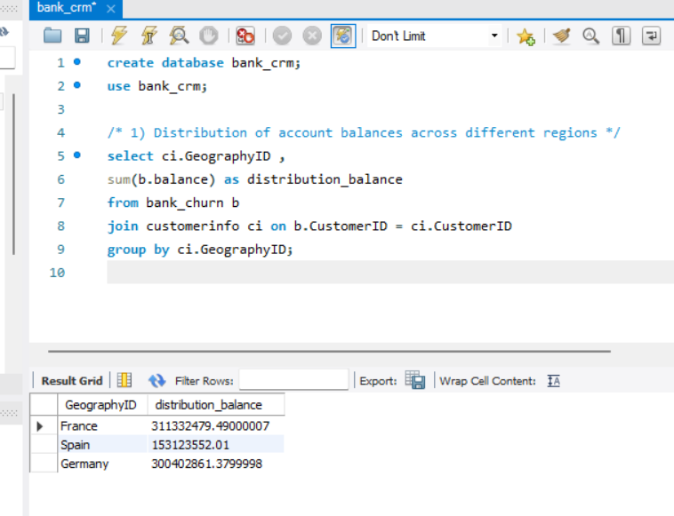

Insights:
- France has the highest balance at 311M , making it the top country in distribution.
- Most of the balance comes from France and Germany, while Spain contributes less.
- Identify the top 5 customers with the highest Estimated Salary in the last quarter of the year. (SQL)
SQL Query:
SELECT
CustomerId,
Surname,
EstimatedSalary,
Bank_DOJ
FROM
customerinfo
WHERE
MONTH(Bank_DOJ) IN (10, 11, 12)
ORDER BY
EstimatedSalary DESC
LIMIT 5;
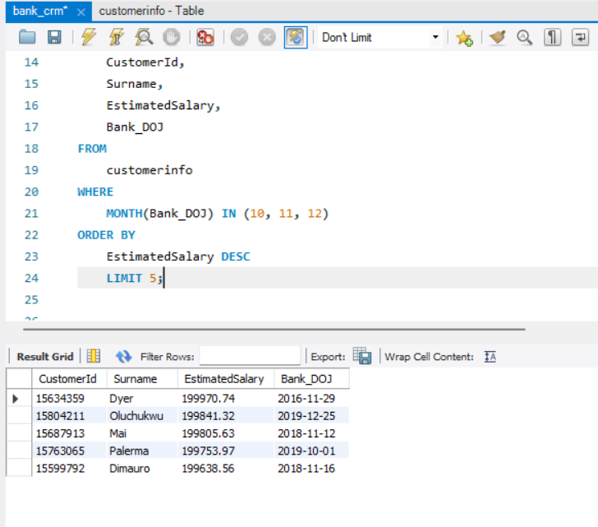
- Calculate the average number of products used by customers who have a credit card. (SQL)
SQL Query:
SELECT
avg(NumOfProducts) as avg_products_with_creditcard
from bank_churn
where HasCrCard = "Creditcard_holder";

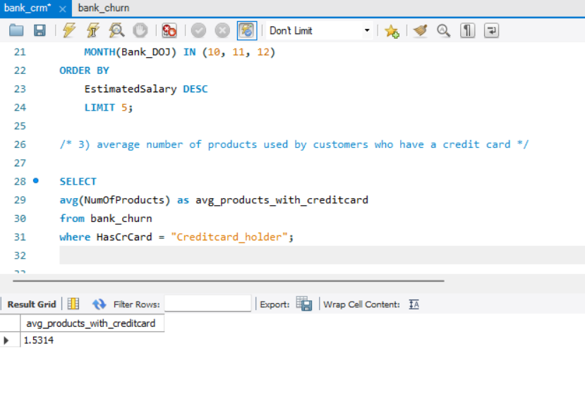

- Determine the churn rate by gender for the most recent year in the dataset.
SQL Query:
WITH RecentYear AS (
SELECT MAX(YEAR(Bank_DOJ)) AS MostRecentYear
FROM CustomerInfo
)
SELECT
ci.GenderID,
COUNT(*) AS total_customers,
SUM(bc.Exited) AS churned_customers,
ROUND(SUM(bc.Exited) * 100 / COUNT(*), 2) AS churn_rate_percent
FROM CustomerInfo ci
JOIN Bank_Churn bc
ON ci.CustomerId = bc.CustomerId
JOIN RecentYear r
ON YEAR(ci.Bank_DOJ) = r.MostRecentYear
GROUP BY ci.GenderID;
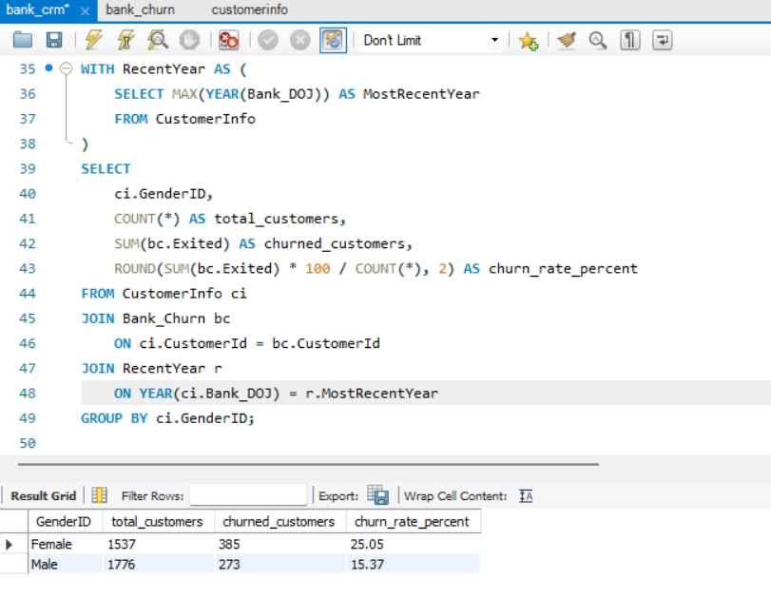
Insights:
- Female customers have a churn rate of 25% more than Males.
Recommendations:
- The bank should focus on understanding why female customers are leaving and design retention program to reduce this gap.
- Compare the average credit score of customers who have exited and those who remain. (SQL)
SQL Query:
SELECT
Exited,
ROUND(AVG(CreditScore), 2) AS avg_credit_score,
COUNT(*) AS total_customers
FROM bank_churn
GROUP BY Exited;

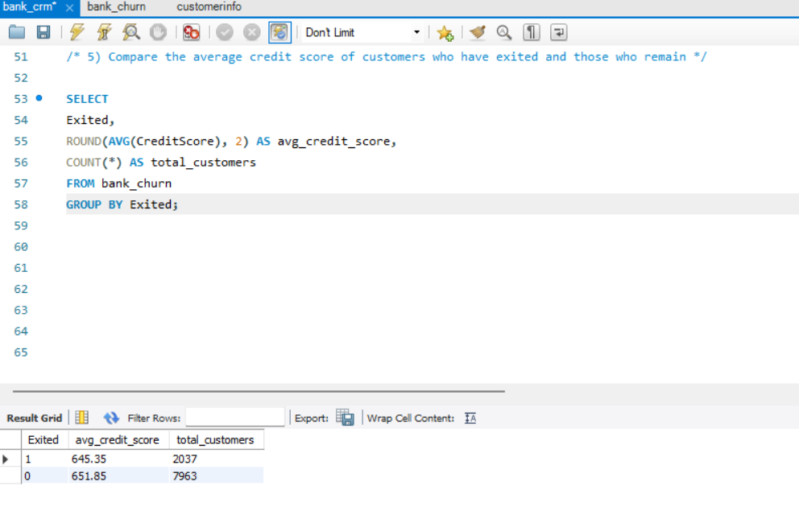
Insights:
- Customers who Exited had an average credit score 645,while those who stayed had 652.
- The difference is small , so credit score alone is not a strong predictor of churn.
Recommendations:
- Don’t rely only on a credit score for churn prediction – include multiple factors (tenure, number of products, customer activity.)
- Which gender has a higher average estimated salary, and how does it relate to the number of active accounts? (SQL)
SQL Query:
SELECT
c.GenderID,
ROUND(AVG(c.EstimatedSalary), 2) AS AvgEstimatedSalary,
COUNT(b.Exited) AS ActiveAccounts
FROM CustomerInfo c
JOIN Bank_Churn b
ON c.CustomerId = b.CustomerId
WHERE b.Exited = "0"
GROUP BY c.GenderID
ORDER BY AvgEstimatedSalary DESC;

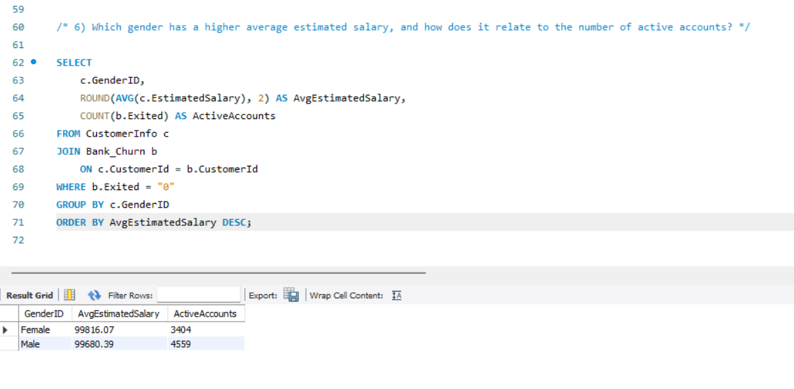
Insights:
- Female customers have a slightly higher average estimated salary compared to males.
- Males have more active accounts than females.
Recommendations:
- Since female earn slightly more but are less active , the bank should design campaign to encourage more product adoption(credit cards , loans,investments).
- Segment the customers based on their credit score and identify the segment with the highest exit rate. (SQL)
SQL Query:
To segment the customers based on their credit score , I have defined the segment as given below:
Low: CreditScore < 600
Medium: 600 ≤ CreditScore < 700
High: CreditScore ≥ 700

SQL query:
SELECT
CASE
WHEN CreditScore < 600 THEN 'Low'
WHEN CreditScore BETWEEN 600 AND 699 THEN 'Medium'
ELSE 'High'
END AS CreditSegment,
COUNT(*) AS TotalCustomers,
SUM(Exited) AS ExitedCustomers,
ROUND(AVG(Exited) * 100, 2) AS ExitRatePercentage
FROM bank_churn
GROUP BY
CASE
WHEN CreditScore < 600 THEN 'Low'
WHEN CreditScore BETWEEN 600 AND 699 THEN 'Medium'
ELSE 'High'
END
ORDER BY ExitRatePercentage DESC;
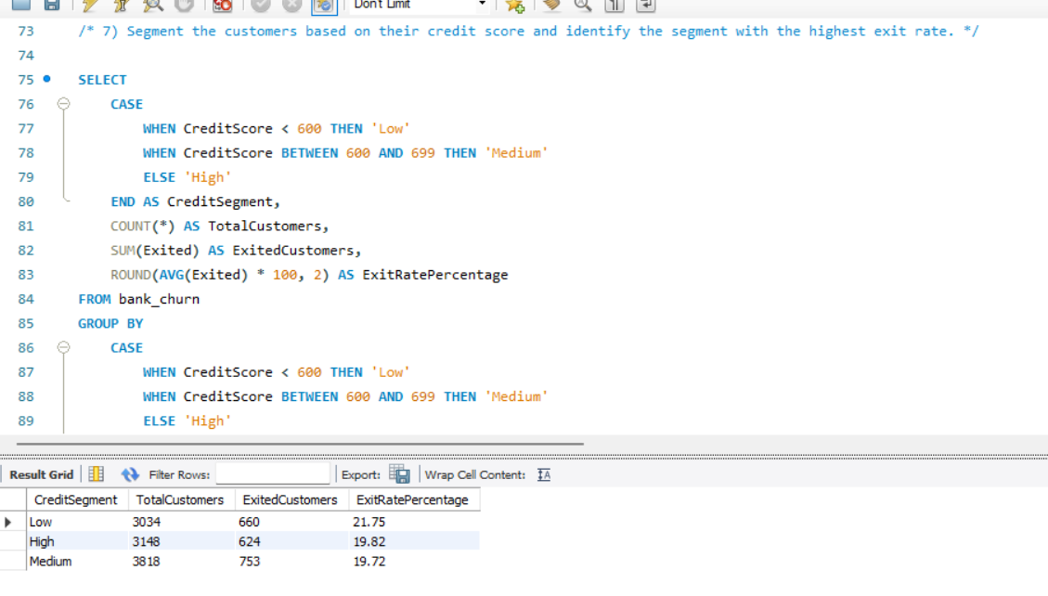
Insights:
- Customers with low credit score have the highest churn rate , making them the riskiest group.
- Customers in the High and medium credit segments churn less
Recommendations:
- Help Low score customers by offering easy repayment plans.
- Keep medium score customers engaged with special offers or discounts.
- Protect high score customers with premium service.
- Find out which geographic region has the highest number of active customers with a tenure greater than 5 years. (SQL)
SQL Query:
SELECT
ci.GeographyID AS Region,
COUNT(*) AS ActiveCustomersWithHighTenure
FROM bank_churn bc
JOIN customerinfo ci ON bc.CustomerId = ci.CustomerId
WHERE bc.Exited = 0
AND bc.Tenure > 5
GROUP BY ci.GeographyID
ORDER BY ActiveCustomersWithHighTenure DESC
LIMIT 1;

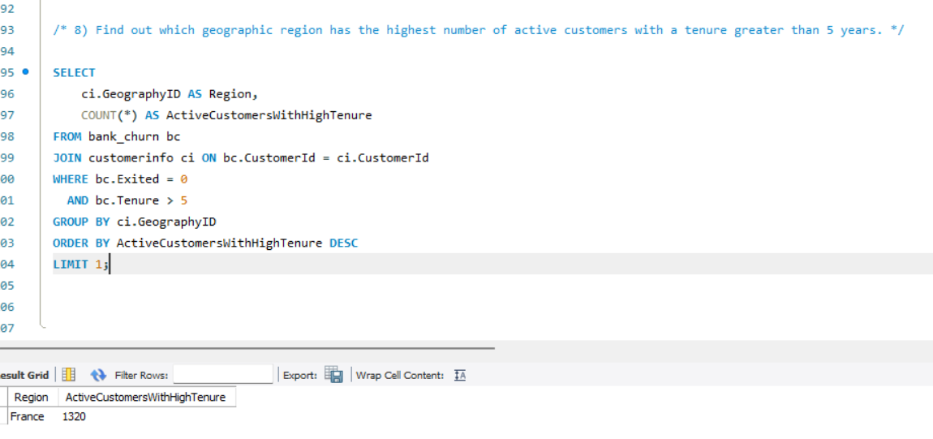
Insights:
- France is the highest number of active customers with a tenure greater than 5 Years.
- What is the impact of having a credit card on customer churn, based on the available data?
SQL Query:
SELECT
HasCrCard,
COUNT(*) AS TotalCustomers,
SUM(Exited) AS ExitedCustomers,
ROUND(AVG(Exited) * 100, 2) AS CustomerChurnPercentage
FROM bank_churn
GROUP BY HasCrCard;

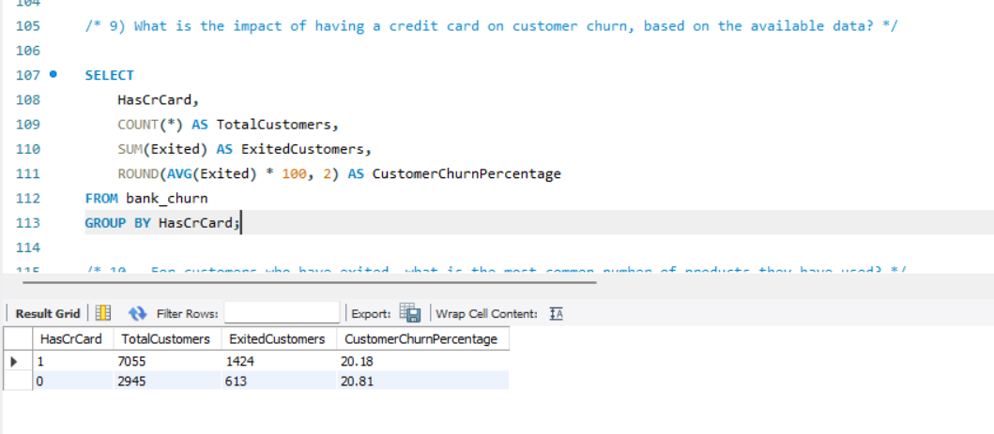
Insights:
- The Churn Rate is almost the same whether the customer have a credit card or not.
- Having a credit card does not strongly effect the customer churn.
- For customers who have exited, what is the most common number of products they have used?
SQL Query:
SELECT
NumOfProducts,
COUNT(*) AS ExitedCustomerCount
FROM bank_churn
WHERE Exited = 1
GROUP BY NumOfProducts
ORDER BY ExitedCustomerCount DESC
LIMIT 1;
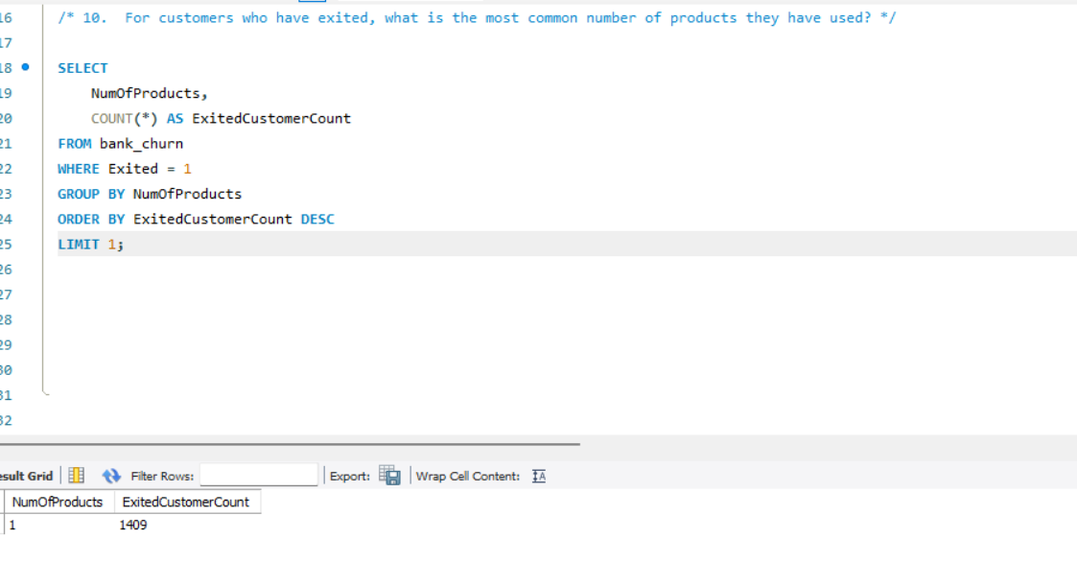
Insights:
- 1 is the most common number of products used by the customers who have exited.

- Examine the trend of customers joining over time and identify any seasonal patterns (yearly or monthly). Prepare the data through SQL and then visualize it.
SQL Query:
SELECT
YEAR(Bank_DOJ) AS JoinYear,
MONTH(Bank_DOJ) AS JoinMonth,
COUNT(*) AS CustomersJoined
FROM customerinfo
GROUP BY YEAR(Bank_DOJ), MONTH(Bank_DOJ)
ORDER BY JoinYear, JoinMonth;

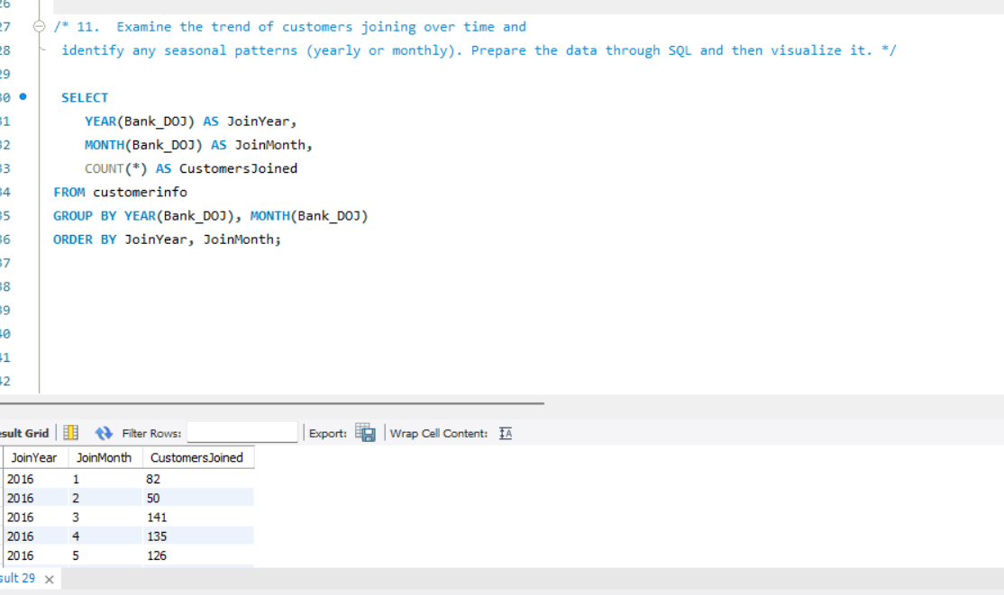

Insights:
- Customer acquisition increased year by year.
- Peak Joining months are September to December, with December being the highest.
- Early months (Jan – March ) have lower new joins compare to later months.
- 2019 has the highest growth, showing strong improvement.
Recommendations:
- Analyze the success of 2019 strategies , continue or enhance actions taken that led to strong growth.

- Analyze the relationship between the number of products and the account balance for customers who have exited.
SQL Query:
SELECT
NumOfProducts,
COUNT(*) AS ExitedCustomers,
ROUND(AVG(Balance), 2) AS AvgBalance
FROM bank_churn
WHERE Exited = 1
GROUP BY NumOfProducts
ORDER BY NumOfProducts;
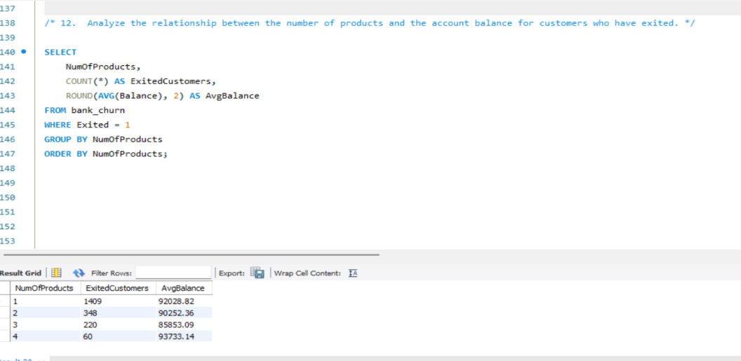

Insights:
- Most Exited customers have only 1 Product.
- Customers with 2 products also exited but in smaller number.
- 3 and 4 products have very small exits.
- Average balances are quite high across all groups indicates that wealthier customers are also churning , not just low-value ones.
Recommendations:
- Focus on single-product customers since they are the largest group churning , create campaigns to encourage them to adopt 2 products.
- Customers with high balances are valuable , offer VIP support, relationship managers.

- Identify any potential outliers in terms of balance among customers who have remained with the bank.
SQL Query:
Step 1: Get total count of active customers
SELECT COUNT(*) AS TotalActive FROM bank_churn WHERE Exited = 0;
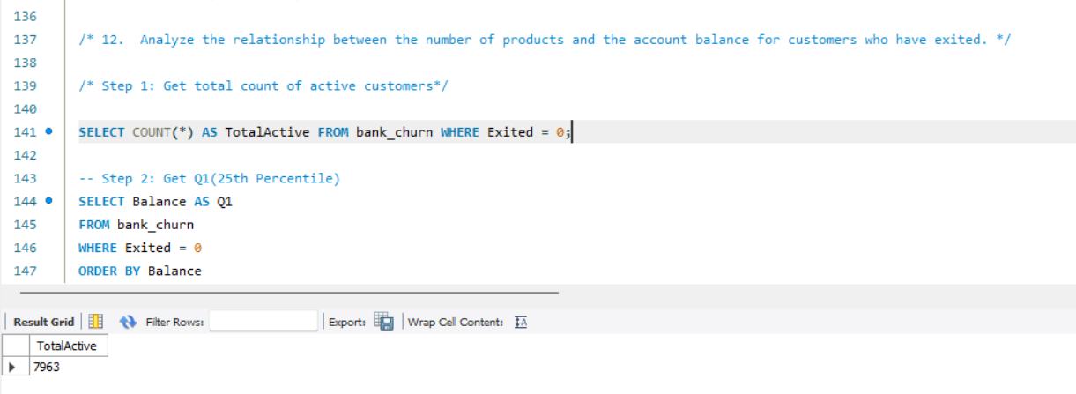

-- Step 2: Get Q1(25th Percentile)
SELECT Balance AS Q1
FROM bank_churn
WHERE Exited = 0
ORDER BY Balance
LIMIT 1 OFFSET 1989;
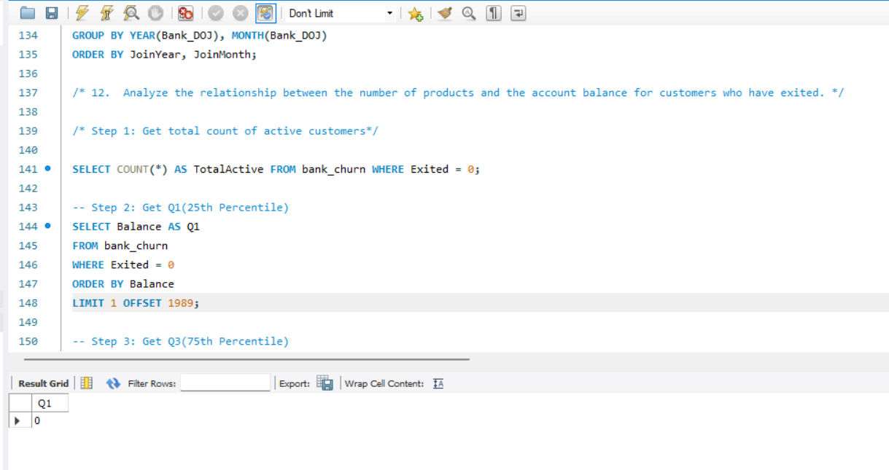

-- Step 3: Get Q3(75th Percentile)
SELECT Balance AS Q3
FROM bank_churn
WHERE Exited = 0
ORDER BY Balance
LIMIT 1 OFFSET 5971;
-- Step 4: To find Outliers
SELECT *
FROM bank_churn
WHERE Exited = 0
AND Balance > 315980.45;
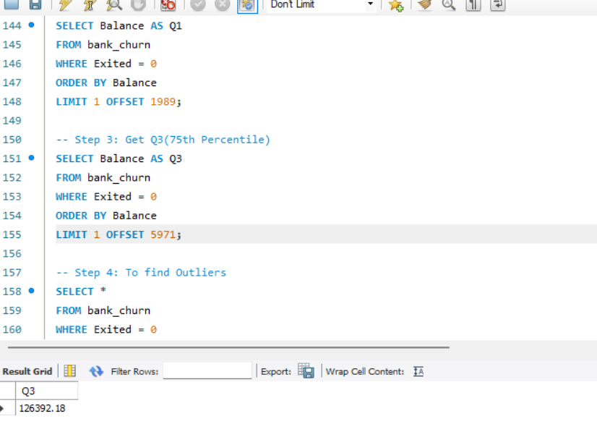
To Find Percentile Positions:
- Q1(25th percentile) = 0.25×7963=1990.75 ……>UseOFFSET1989
- Q3 (75th percentile) = 0.75 × 7963 = 5972.25 …….>Use OFFSET 5971
To Calculate IQR and Thresholds:
IQR=Q3−Q1=126,392.18−0=₹126,392.18
LowerBound= Q1−1.5×IQR=0−189,588.27=−₹189,588.27
(Ignorethis; balance can't be negative)
Upper Bound = Q3 + 1.5 × IQR = 126,392.18 + 189,588.27 = ₹315,980.45
Final Outlier Result:
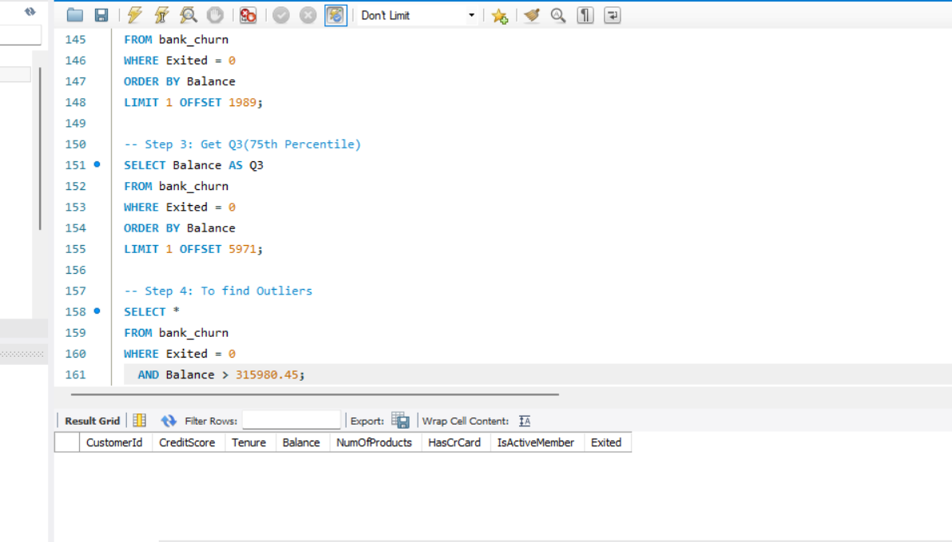
There are no significant high-balance outliers among active customers, based on the IQR method.

What This Tells Us:
- Q1 = ₹0 means at least 25% of active customers have no balance at all.
- Q3 = ₹126,392.18 implies 75% of customers have balances below this.
- Since no active customer exceeds ₹3.15 lakhs, the distribution of balance is skewed toward the lower end with no extreme high values.

- How many different tables are given in the dataset, out of these tables which table only consists of categorical variables?’
SQL Query:
There are seven different tables in the dataset:
- ActiveCustomer (ActiveID ,ActiveCategory)
- Bank_Churn (CustomerId, CreditScore, Tenure, Balance, NumOfProducts, HasCrCard, IsActiveMember, Exited)
- CreditCard (CreditID, Category)
- CustomerInfo (CustomerId, Surname, Age, GenderID, EstimatedSalary, GeographyID, Bank DOJ)
- ExitCustomer (Bank DOJ, ExitCategory)
- Geography (GeographyID, GeographyLocation)

- Gender (GenderID, GenderCategory)

Tables only with Pure Categorical(Binary) Variables:
- Gender
- Geography
- Exitcustomer
- CreditCard
- ActiveCustomer
Technically Stores numerical value but conceptually it represents categories.

- Using SQL, write a query to find out the gender-wise average income of males and females in each geography id. Also, rank the gender according to the average value. (SQL)
SQL Query:
SELECT
GeographyID,
GenderID,
AVG(EstimatedSalary) AS Avg_Income,
RANK() OVER (PARTITION BY GeographyID ORDER BY AVG(EstimatedSalary) DESC) AS Income_Rank
FROM
customerinfo
GROUP BY
GeographyID,
GenderID;
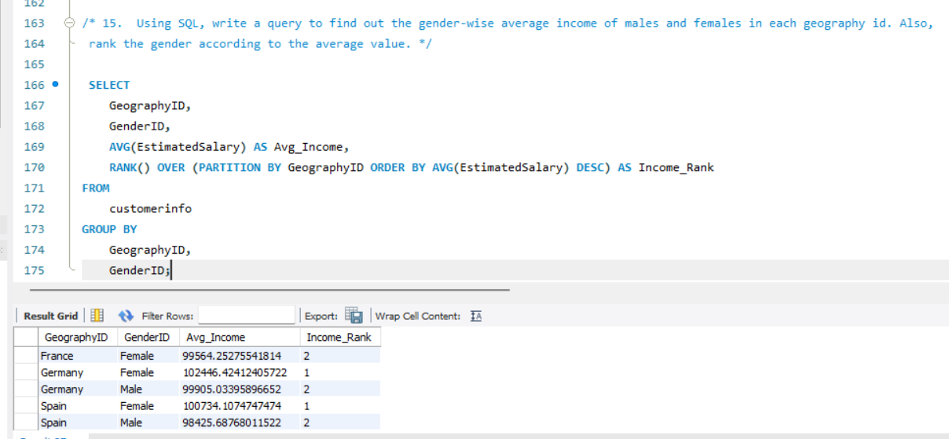

Insights:
- Germany has the highest Female average income , higher than all other groups.
- In France, Male earn slightly more than Females , but in Spain and Germany females earn more.
- Spain shows the lowest Male income, showing Major gender gap in that country.
Recommendations:
- Target Female Customers in Germany and Spain , with premium financial product , since they show higher income levels.

- Using SQL, write a query to find out the average tenure of the people who have exited in each age bracket (18-30, 30-50, 50+).
SQL Query:
SELECT
CASE
WHEN Age BETWEEN 18 AND 30 THEN '18-30'
WHEN Age BETWEEN 31 AND 50 THEN '31-50'
ELSE '51+'
END AS Age_Bracket,
AVG(Tenure) AS Avg_Tenure
FROM
bank_churn bc
JOIN
customerinfo ci ON bc.CustomerId = ci.CustomerId
WHERE
Exited = 1
GROUP BY
CASE
WHEN Age BETWEEN 18 AND 30 THEN '18-30'
WHEN Age BETWEEN 31 AND 50 THEN '31-50'
ELSE '51+'
END;
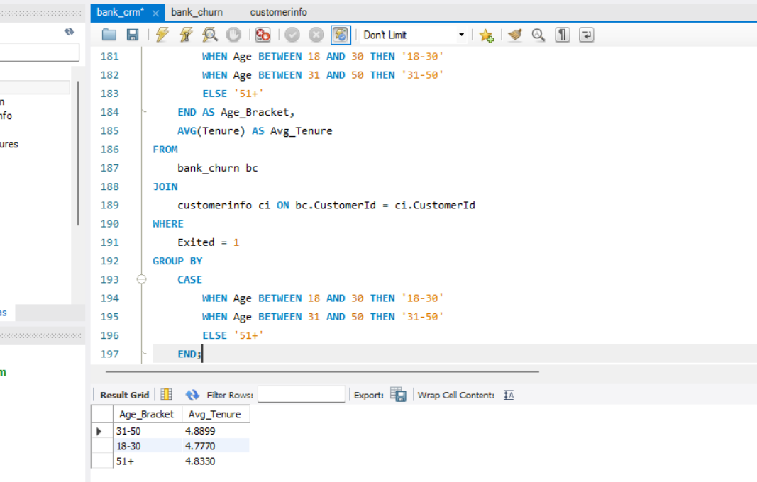
Insights:
- Customers aged 31-50 has the highest average tenure , showing stronger loyalty compared to other groups.
- Young Customers aged 18-30has the lowest average tenure.
- Customers aged 51+ also shows relatively stable tenure.
Recommendations:
- Retention focus on young customers, offers personalised onboarding to increase long term engagement.

- Is there any direct correlation between salary and the balance of the customers? And is it different for people who have exited or not?
To determine the correlation between salary and balance of the customer, I have use excel formula
For Active Customers:
=CORREL(FILTER(D:D,H:H=0),FILTER('CustomerInfo (2)'!E:E,Bank_Churn!H:H=0))
Correlation of Active customers = 0.017199
For Exited Customers:
=CORREL(FILTER(D:D,H:H=1),FILTER('CustomerInfo (2)'!E:E,Bank_Churn!H:H=1))
Correlation for Exited Customers:-0.01254

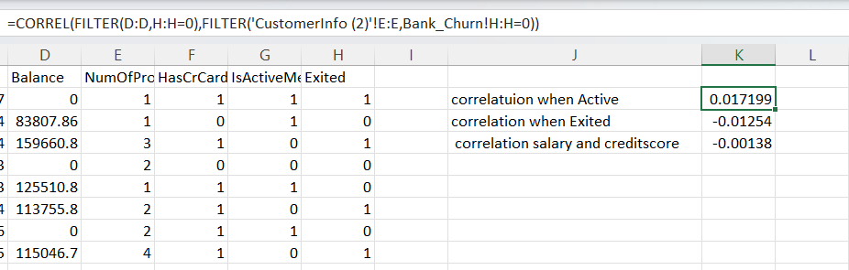

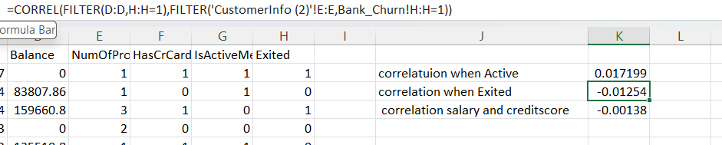

Insights:
- For Exited customers , the correlation between EstimatedSalary and Balance is slightly Negative meaning salary and balance have almost no relationship , but higher salary doesn’t necessarily prevent churn.
- For non-exited customers , the correlation is positive , still very weak , but it suggests higher salary may be marginally associated with maintaining balance and retention.
Recommendations:
- Do not rely solely on income or balance to predict churn - instead focus on behavioral factors (product usage).

- Is there any correlation between the salary and the Credit score of customers?
To determine the correlation Between salary and Credit Score of customers , I have used EXCEL formula
=CORREL(CustomerInfo!E:E,Bank_Churn!B:B)
Correlation Between Salary and Credit score is -0.00138
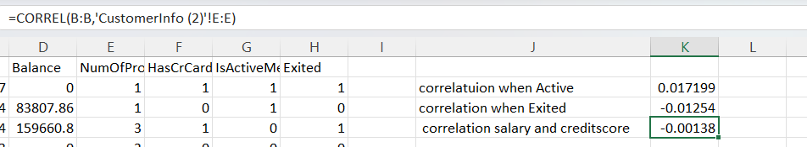
Insights:
- The Correlation Between Salary and Credit score is -0.00138,which is almost zero. This means there is no meaningful relationship between how much customers earn and their credit score.
- Customers with higher salary do not necessarily have better credit score and vice versa.
Recommendations:
- Salary alone does not reflect repayment behavior , use other factors(payment history, number of products, tenure ) for customer risk assessment and churn analysis.

- Rank each bucket of credit score as per the number of customers who have churned the bank.
SQL Query:
SELECT
CreditScoreBucket,
ChurnedCustomers,
RANK() OVER (ORDER BY ChurnedCustomers DESC) AS Rnk
FROM (
SELECT
CASE
WHEN CreditScore BETWEEN 300 AND 499 THEN '300-499'
WHEN CreditScore BETWEEN 500 AND 599 THEN '500-599'
WHEN CreditScore BETWEEN 600 AND 699 THEN '600-699'
WHEN CreditScore BETWEEN 700 AND 799 THEN '700-799'
WHEN CreditScore BETWEEN 800 AND 900 THEN '800-900'
ELSE 'Other'
END AS CreditScoreBucket,
COUNT(*) AS ChurnedCustomers
FROM bank_churn
WHERE Exited = 1
GROUP BY CreditScoreBucket
) AS BucketCounts
ORDER BY Rnk;

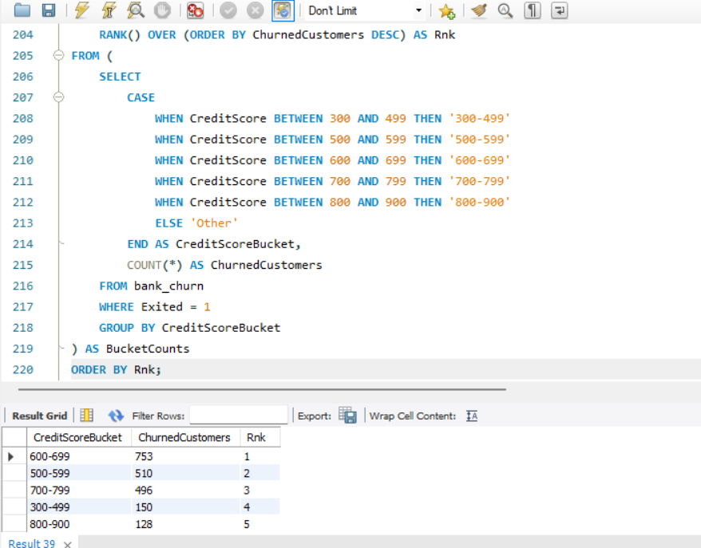

Insights:
- High churns are in the 600-699 bucket.
- Lower scores (300-499) also show significant churn, suggesting financial instability may drive exists.
- High credit scores customers (800-900) have the lowest churn , they are almost loyal and stable.
Recommendations:
- Focus retention efforts on mid-credit score customers (600-699) , offer better service to reduce churn.

- According to the age buckets find the number of customers who have a credit card. Also retrieve those buckets that have lesser than average number of credit cards per bucket.
SQL Query:
WITH AgeBuckets AS (
SELECT
CASE
WHEN ci.Age BETWEEN 18 AND 25 THEN '18-25'
WHEN ci.Age BETWEEN 26 AND 35 THEN '26-35'
WHEN ci.Age BETWEEN 36 AND 45 THEN '36-45'
WHEN ci.Age BETWEEN 46 AND 55 THEN '46-55'
WHEN ci.Age BETWEEN 56 AND 65 THEN '56-65'
WHEN ci.Age > 65 THEN '65+'
ELSE 'Unknown'
END AS AgeBucket,
bc.HasCrCard
FROM customerinfo ci
JOIN bank_churn bc ON ci.CustomerId = bc.CustomerId
),
CreditCardCounts AS (
SELECT
AgeBucket,
COUNT(*) AS TotalCustomers,
SUM(CASE WHEN HasCrCard = 1 THEN 1 ELSE 0 END) AS CreditCardHolders
FROM AgeBuckets
GROUP BY AgeBucket
),
AverageCardHolders AS (
SELECT AVG(CreditCardHolders) AS AvgCardHoldersPerBucket
FROM CreditCardCounts
)
SELECT
c.AgeBucket,
c.CreditCardHolders
FROM CreditCardCounts c
JOIN AverageCardHolders a
ON c.CreditCardHolders < a.AvgCardHoldersPerBucket;
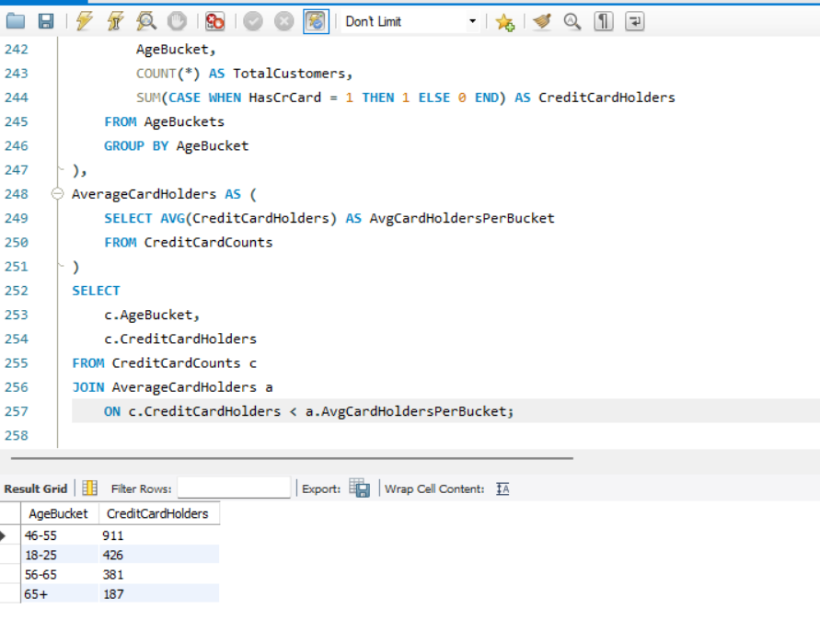

Insights:
- Most of the credit card holders are in the age group(46-55).
- Young adults (18-25) also show strong adoption , meaning early financial product usage is growing.
- Senior customers (65+) have the lowest card holding.
Recommendations:
- Target 46-55 age group with premium cards and loyalty programs , since they are the largest segment.
- Engage 18-25 age group customers with student/entry level card to build long term loyalty.

- Rank the Locations as per the number of people who have churned the bank and average balance of the customers.
SQL Query:
SELECT
Location,
Num_Churned_Customers,
Avg_Balance,
RANK() OVER (ORDER BY Num_Churned_Customers DESC, Avg_Balance DESC) AS Location_Rank
FROM (
SELECT
ci.GeographyID AS Location,
COUNT(CASE WHEN bc.Exited = 1 THEN 1 END) AS Num_Churned_Customers,
AVG(bc.Balance) AS Avg_Balance
FROM
customerinfo ci
JOIN
bank_churn bc ON ci.CustomerId = bc.CustomerId
GROUP BY
ci.GeographyID
) AS RankedLocations;
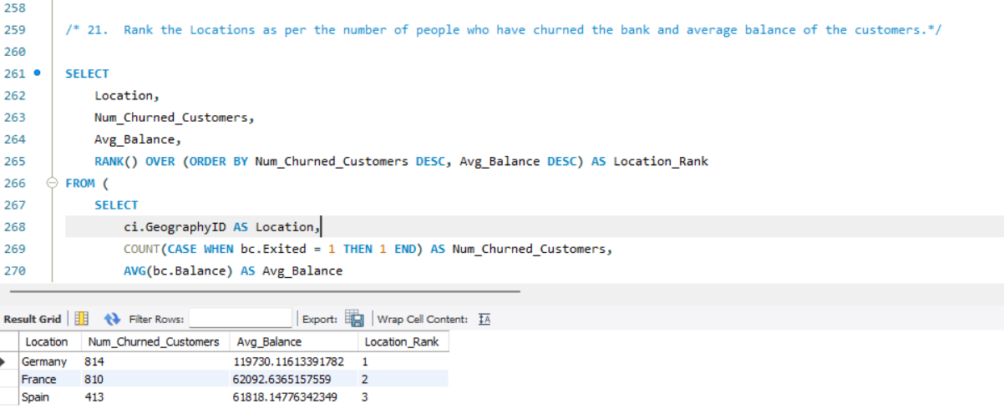

Insights:
- Germany has the highest churns with highest average balance, means high value customers are leaving.
- Francehas nearly equal churn but with much lower average balance , many customers are leaving but less financial effect.
- Spainshows lowest churn, means customer retention is higher.
Recommendations:
- Focus on Germany first, design exclusive retention offers.
- As we can see that the “CustomerInfo” table has the CustomerID and Surname, now if we have to join it with a table where the primary key is also a combination of CustomerID and Surname, come up with a column where the format is “CustomerID_Surname”.
As we have not a second table where the primary key is also a combination of CustomerID and Surname, so I have assumed that the second table is called CustomerDetailsand has a column named CustomerID_Surname.
SQl Query :
SELECT
ci.CustomerID,
ci.Surname,
cd.*
FROM
CustomerInfo ci
JOIN
CustomerDetails cd
ON CONCAT(ci.CustomerID, '_', ci.Surname) = cd.CustomerID_Surname;

What it Does:
- Dynamically constructs a CustomerID_Surname key from the CustomerInfo table.
Joins it with the same composite key in CustomerDetails.
- Without using “Join”, can we get the “ExitCategory” from ExitCustomers table to Bank_Churn table? If yes do this using SQL.
Yes, we can add the ExitCategory from the ExitCustomers table to the Bank_Churn table without using a JOIN, by using a subquery or CASE expression.
Since ExitIDin ExitCustomers corresponds directly to the Exited column in Bank_Churn, we can map it using a correlated subquery or a CASE statement.
SQL query:
SELECT
CustomerId,
CreditScore,
Tenure,
Balance,
NumOfProducts,
HasCrCard,
IsActiveMember,
Exited,
CASE
WHEN Exited = 1 THEN 'Exit'
WHEN Exited = 0 THEN 'Retain'
ELSE 'Unknown'
END AS ExitCategory
FROM
Bank_Churn;

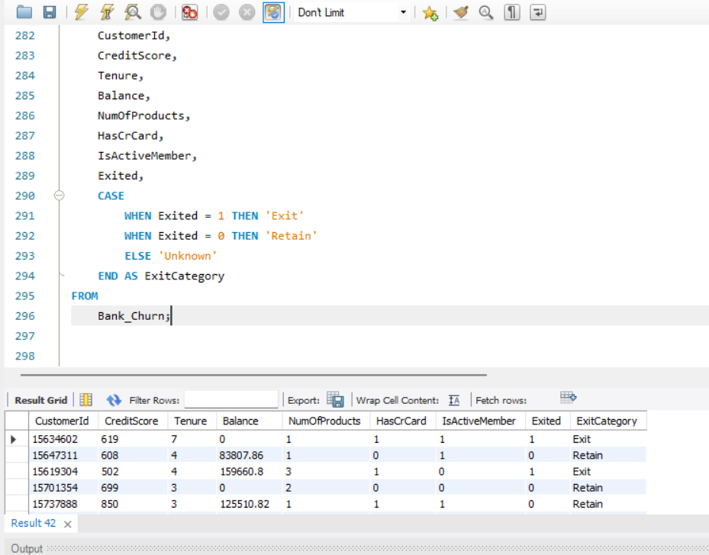

- Were there any missing values in the data, using which tool did you replace them and what are the ways to handle them?
There were no missing values in any of the tables.
I will find out the missing values in EXCEL using Filter
If there is any missing values, I handled missing values using SQL tool COALESCE.
IF missing values are there, Ways to Handle them:
- Dropping the missing values
- Filling with Mean/Median/Mode
- Write the query to get the customer IDs, their last name, and whether they are active or not for the customers whose surname ends with “on”.
SQL Query:
SELECT ci.CustomerId,
ci.Surname,
bc.Exited
FROM customerinfo ci
JOIN bank_churn bc ON ci.CustomerId = bc.CustomerId
WHERE ci.Surname LIKE '%on';

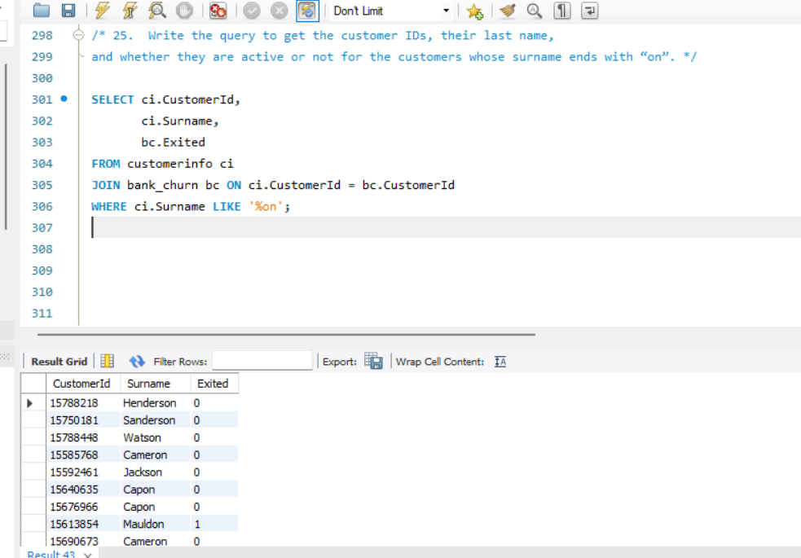
These are the customers whose surnames ends with “on” and their activity status.
- Can you observe any data disrupency in the Customer’s data? As a hint it’s present in the IsActiveMember and Exited columns. One more point to consider is that the data in the Exited Column is absolutely correct and accurate.

Yes, there is a data discrepancy in the IsActiveMember and Exited Columns.
IsActiveMemberindicates whether the customer is actively engaged with the bank or not.
Exited indicates whether the customer left the bank or not
Likely Discrepancy, some customers are inactive but not churned, the likelihood of churn is high. Some customers are active but churned,if churn is confirmed, then the customer cannot remain active, this again shows inconsistency in IsActiveMember flag.

Subjective Question:

- Customer Behavior Analysis: What patterns can be observed in the spending habits of long-term customers compared to new customers, and what might these patterns suggest about customer loyalty?
Step 1 :
Long term customers : Tenure >=5 Years
New Customers : Tenure <= 2 years
Step 2 :
Spending and Engagement Proxies:
Balance : High balance indicates high savings
EstimatedSalary : Indicates how much power he has to spend
IsActiveMember : Customer engagement with banking services
Exited: Helps to know the loyalty of the customer with spending/engagement
SQL Query :
SELECT
CASE
WHEN b.Tenure>= 5 THEN 'Long-Term'
WHEN b.Tenure<= 2 THEN 'New'
ELSE 'Mid-Term'
END AS Customer_Type,
COUNT(*) AS Total_customers,
ROUND(AVG(b.Balance), 2) AS AvgBalance,
ROUND(AVG(c.EstimatedSalary), 2) AS AvgSalary,
ROUND(AVG(b.Exited) * 100, 2) AS ChurnRate_Percent,
ROUND(AVG(b.IsActiveMember) * 100, 2) AS ActiveRate_Percent
FROM
CustomerInfo c
JOIN
Bank_Churn b ON c.CustomerId = b.CustomerId
GROUP BY CASE
WHEN b.Tenure>= 5 THEN 'Long-Term'
WHEN b.Tenure<= 2 THEN 'New'
ELSE 'Mid-Term'
END;
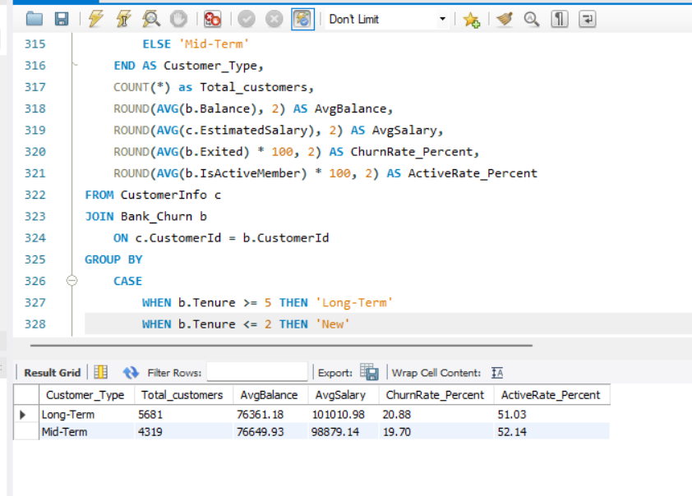

Insights:
- Long-term customers forms the largest segment compared to Mid-term customers.
- Mid-term customers maintain higher average balance and salaries compared to Long-term customers. This indicates that Mid-term customers are financially stronger despite lower tenure.
- Churn rate is slightly higher among Long-term customers than Mid-term customers.
Recommendations:
- Reduce churn for Long-term customers by offering personalized offers, loyalty rewards.
- Engage Mid-term customers, since they have higher balances and salaries target them with premium products before they churn.
- Product Affinity Study: Which bank products or services are most commonly used together, and how might these influence cross-selling strategies?
The key variables considered include:
- NumOfProducts (total number of products a customer uses)
- HasCrCard (1 = has credit card)
- Balance > 0 (proxy for savings/investment usage)
- Exited (engagement indicator)
SQL query:
SELECT
-- Product affinity combinations
SUM(CASE WHEN bc.HasCrCard = 1 AND bc.Balance > 0 THEN 1 ELSE 0 END) AS CrCard_And_Savings,
SUM(CASE WHEN bc.HasCrCard = 1 AND bc.NumOfProducts >= 2 THEN 1 ELSE 0 END) AS CrCard_And_MultiProduct,
SUM(CASE WHEN bc.Balance > 0 AND bc.NumOfProducts >= 2 THEN 1 ELSE 0 END) AS Savings_And_MultiProduct,
SUM(CASE WHEN bc.HasCrCard = 1 AND bc.Exited = 1 THEN 1 ELSE 0 END) AS CrCard_And_Active,
SUM(CASE WHEN bc.NumOfProducts = 1 AND ci.EstimatedSalary > 100000 THEN 1 ELSE 0 END) AS HighSalary_SingleProduct,
COUNT(*) AS TotalCustomers
FROM bank_churn bc
JOIN customerinfo ci
ON bc.CustomerId = ci.CustomerId;
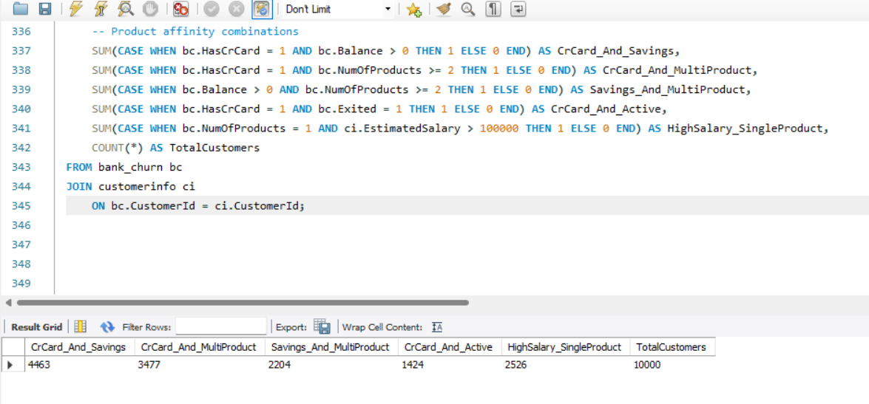

Insights:
- The largest segment holds both credit card and savings balances. Indicates strong good relationship depth.
- Customers hold credit card and multiple products suggests that bundled offerings and cross-sell strategies are working well.
- 2204 customers maintain savings with multiple products shows opportunities to further push credit card adoption.
- Credit card customers are vulnerable to churn.
- High income customers uses single product, this is a major cross-sell opportunity , since they have strong financial capacity but low engagement.
Recommendations:
- Strength: Most customers have multiple products showing success in cross-selling.
- Risk: Credit card holders show notable churn risk, retention program should target in this group.
- Opportunity: High – income single – product customers should be prioritised for up selling premium credit cards, loans or investment products.
- Geographic Market Trends: How do economic indicators in different geographic regions correlate with the number of active accounts and customer churn rates?

The key columns analyzed:
- EstimatedSalary (economic indicator)
- IsActiveMember and Exited (activity and churn indicators)
- Geography (France, Spain, Germany)
SQL query:
SELECT
c.GeographyID AS Region,
COUNT(c.CustomerId) AS Total_Customers,
AVG(c.EstimatedSalary) AS Avg_Estimated_Salary,
SUM(CASE WHEN b.Exited = 0 THEN 1 ELSE 0 END) * 100.0 / COUNT(*) AS Active_Percentage,
SUM(CASE WHEN b.Exited = 1 THEN 1 ELSE 0 END) * 100.0 / COUNT(*) AS Churn_Percentage
FROM
customerinfo c
JOIN
bank_churn b ON c.CustomerId = b.CustomerId
GROUP BY
c.GeographyID;
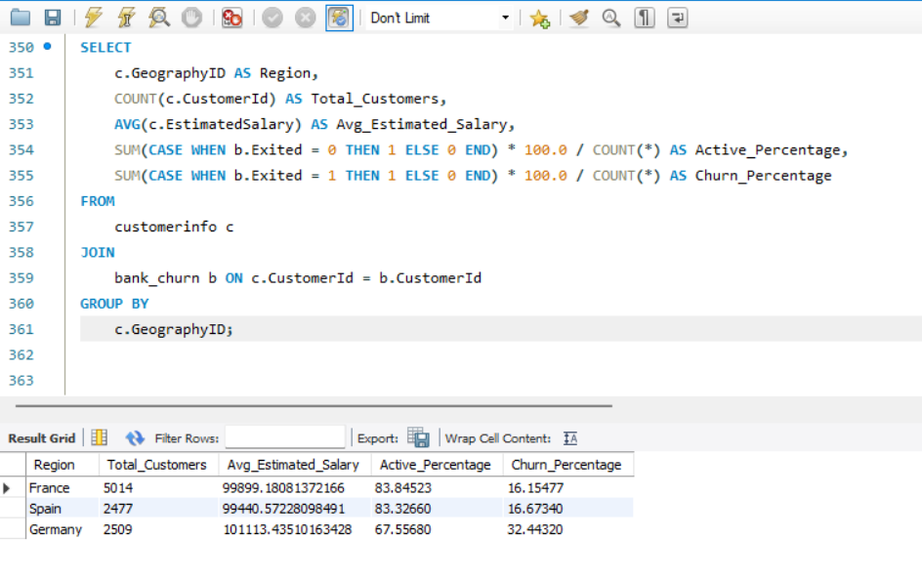

Insights:
- France has the largest customer base with strong engagement and the lowest churn.
- Spain has fewer customers with similar active rate and churn, showing stability.
- Germany has the smallest base but much higher churn and lower activity, signalling risk.
Recommendations:
- Strengthen retention efforts in Germany with targeted engagement programs and incentives to reduce churn.
- Maintain and reinforce customer loyalty strategies in France and Spain to sustain their strong performance.

- Risk Management Assessment: Based on customer profiles, which demographic segments appear to pose the highest financial risk to the bank, and why?
Segmentation Criteria:
- Region (Geography): To understand regional variations in risk.
- Age Group: Bucketed into 10-year bands (e.g., 20s, 30s) to analyze generational behavior.
SQL Query:
SELECT
c.GeographyID AS Region,
FLOOR(c.Age / 10) * 10 AS Age_Group,
COUNT(c.CustomerId) AS Total_Customers,
round(AVG(b.CreditScore),2) AS Avg_CreditScore,
round(AVG(b.Balance),2) AS Avg_Balance,
round(SUM(CASE WHEN b.Exited = 1 THEN 1 ELSE 0 END) * 100.0 / COUNT(*),2) AS Churn_Percentage
FROM
customerinfo c
JOIN
bank_churn b ON c.CustomerId = b.CustomerId
GROUP BY
c.GeographyID, FLOOR(c.Age / 10) * 10
ORDER BY
Churn_Percentage DESC;

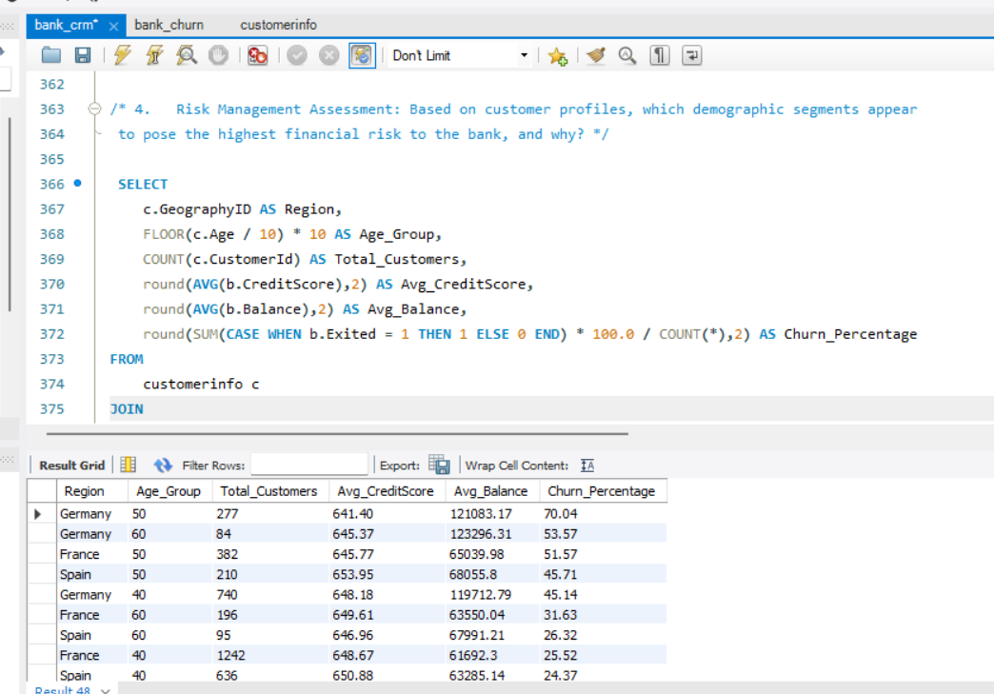

Insights:
- Germany has the highest churn especially in the 50-60 age group with balance above 120k.
- France shows stable Low churn in the younger groups (10-30) , bur churn rises above 50% at age 50.
- Spain maintains relatively lower churn across most age groups , peaking around 45.7% at age 50 but dropping quickly for younger segments.
- Higher balances are linked with higher churn.(especially in Germany)

Recommendations:
- Germany (50-60 age group) : Focus retention campaign here , as they represent highest risk. Personalised financial advice or loyalty incentive could help.
- France (Young customers) Strong loyalty base , offer them with cross-selling opportunities.
- Spain generally healthier retention , but watch out for the 50+ age group.

- Customer Tenure Value Forecast: How would you use the available data to model and predict the lifetime (tenure) value in the bank of different customer segments?
I combined the two tables bank_churn and Customerinfo to get complete data using CustomerID in PowerBi.
To estimate the long-term worth of each customer , I used this formula:
Tenure Value = Tenure × (Balance + (EstimatedSalary / 12))
Next I segemented customers based on their credit score
CustomerSegment = SWITCH(
TRUE(),
[CreditScore] >= 750, "Excellent",
[CreditScore] >= 650, "Good",
"Poor"
)
For Analysis,I plotted power BI visualizations such as Bar Chart and Line chart to track tenure value trends and segment performance.
This approach helped highlight high-value customer groups and provided forward-looking insights into future value patterns , supporting data driven decision making for customer retention and growth strategies.
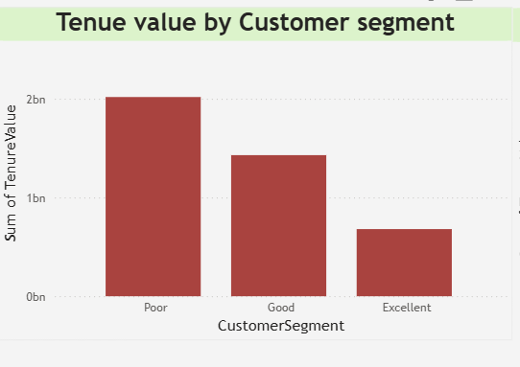

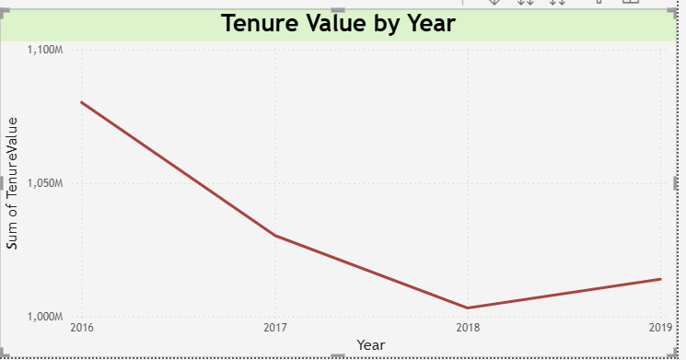
Insights:
- Poor Credit Segment has highest tenure value ,this suggests that even though these customers have low credit scores , they are either staying longer or holding higher balances.
- Excellent segment contributes the least ,customers in the excellent segment shows the lowest tenure value .This may indicate that financially strong customers either churn earlier or maintain lower balances.
- Declining trend in tenure value over time , the lien chart with forecasting shows a steady decline in tenure value starting around 2020.
Recommendations:
- Re-evaluate customer value assumptions, do not assume high credit score customers are always the most valuable, consider targeting the Poor segment with retention offers .
- Adress decline tenure value, the downward trend suggests emerging customer dissatisfaction .It’s time to strengthen onboarding ,cross-selling.
- Monitor tenure trends yearly.
- Marketing Campaign Effectiveness: How could you assess the impact of marketing campaigns on customer retention and acquisition within the dataset? What extra information would you need to solve this?
To measure how marketing affects customer retention and acquisition, the current dataset is helpful for understanding customer behaviour, but it does not include the specific campaign information we needed.
The dataset has two main tables:
Bank_churn : shows customer activity and churn
Customerinfo : included demographic and financial details along with Bank_DOJ, which tells us when a customer joined .
While this data is helpful , it is not enough to directly link customer changes to compaigns. For that we would need an additional marketing_compaign tables with details such as:
CustomerID
CompaignType
CompaignStart and End dates
CustomerResponses
Whether the campaign led to retention or acquisition
With this information, we could connect campaign activity to customer outcomes.
In Power BI, the analysis could include:
- Comparing churn and acquisition before and after campaigns
- Segmenting customers by campaign exposure and response
- Tracking KPIs like retention rate, churn rate, and acquisition growth
- Using visuals like trend lines, cohort analysis, and comparison charts to show campaign impact
In short: The current dataset allows us to study churn and acquisition in general, but without campaign-specific data, we cannot measure the true impact of marketing campaigns. Once campaign data is added, Power BI can be used to build dashboards that clearly show how campaigns influence customer behavior.

- Customer Exit Reasons Exploration: Can you identify common characteristics or trends among customers who have exited that could explain their reasons for leaving?
- I focused on categorical and behavioural variables such as GenderID, GeographyID, NumOfProducts, Tenure, and HasCrCard.
- To move beyond surface-level observations, I chose to calculate churn rates across these customer segments.
- This involved comparing the number of customers who exited versus the total number of customers within each category.
I examined churn rate by:
- Number of Products to assess engagement levels.
- Tenure to understand whether loyalty decays over time.
- Geography to evaluate regional differences in retention.
- Credit Card ownership to see if financial product penetration affects churn.
SQL Query to for number of products:
SELECT
NumOfProducts,
COUNT(*) AS Total_Customers,
SUM(CASE WHEN Exited = 1 THEN 1 ELSE 0 END) AS Exited_Customers,
ROUND(
SUM(CASE WHEN Exited = 1 THEN 1 ELSE 0 END) * 100.0 / COUNT(*),
2
) AS Churn_Rate_Percent
FROM
bank_churn
GROUP BY
NumOfProducts
ORDER BY
Churn_Rate_Percent DESC;
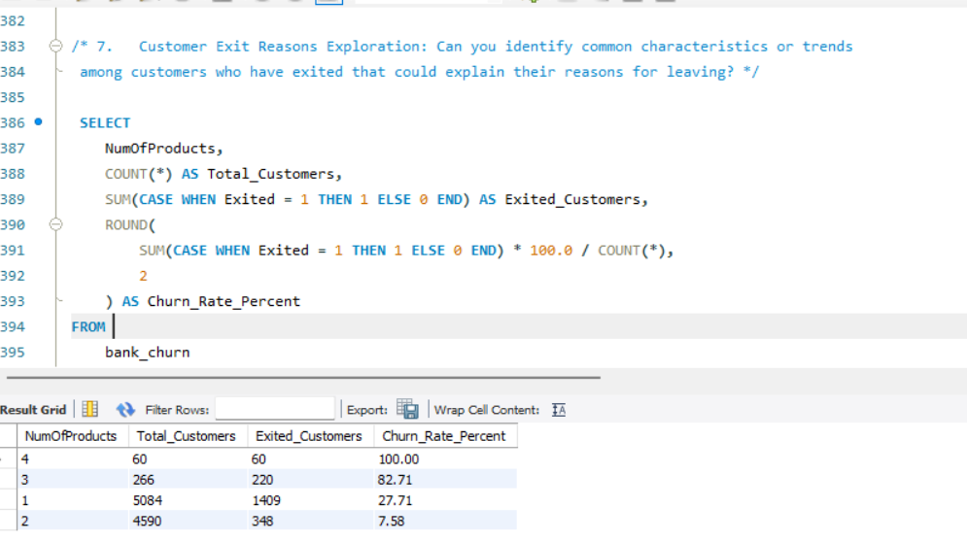

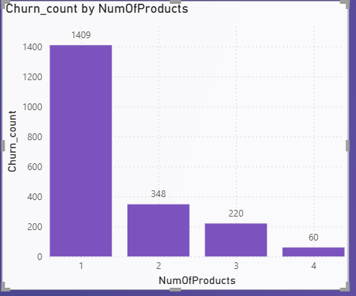
Insights:
- High risk customers with 3 or 4 products ,these are very unstable segments. Almost all multi product customers left.
- Moderate risk with 1 product .
- Low risk with 2 products , this is the most stable and loyal segment.
Recommendations:
- Focus on customers with 3-4 products , because these customers should be the most engaged but instead show extreme dissatisfaction .
Action: Run exit surveys , check complaints , check whether these products overlap or confuse customers.
- Protect the 2-product segment , because they are the most satisfied group.

SQL query for tenure:

SELECT
Tenure,
COUNT(*) AS Total_Customers,
SUM(CASE WHEN Exited = 1 THEN 1 ELSE 0 END) AS Exited_Customers,
ROUND(
SUM(CASE WHEN Exited = 1 THEN 1 ELSE 0 END) * 100.0 / COUNT(*),
2
) AS Churn_Rate_Percent
FROM
bank_churn
GROUP BY
Tenure
ORDER BY
Churn_Rate_Percent DESC;
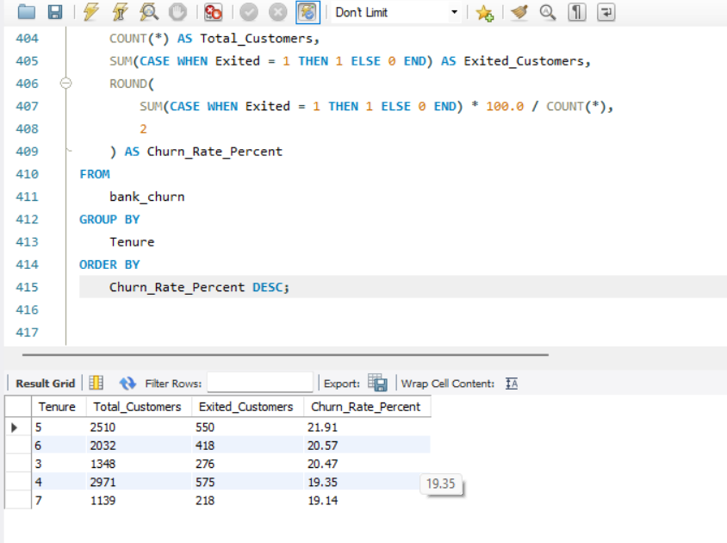

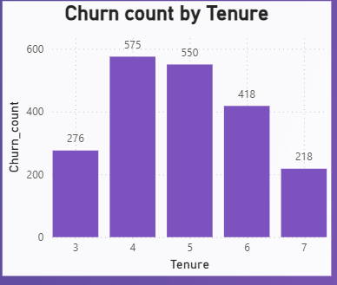
Insights:
- Churn peaks at 4-5 years , showing mid-term disengagement.
- Churn is lowest after 7 years tenure , indicating stronger loyalty among long-term customers.
- Customers in the early tenure also churn less than 4-5 years segment.
Recommendations:
- Focus on proactive engagement at 3-4 years to prevent midterm attrition.
- Strengthen long term retention programs for customers beyond 5 years , rewarding for maintaining their low churn levels.
- Conduct feedback surveys around year 4 to uncover dissatisfaction drivers leading to churn.

SQL Query for Location:
SELECT
c.GeographyID,
COUNT(*) AS Total_Customers,
SUM(CASE WHEN bc.Exited = 1 THEN 1 ELSE 0 END) AS Exited_Customers,
ROUND(
SUM(CASE WHEN bc.Exited = 1 THEN 1 ELSE 0 END) * 100.0 / COUNT(*),
2
) AS Churn_Rate_Percent
FROM
bank_churn bc
join customerinfo c
on bc.customerID = c.customerID

GROUP BY
c.GeographyID
ORDER BY
Churn_Rate_Percent DESC;
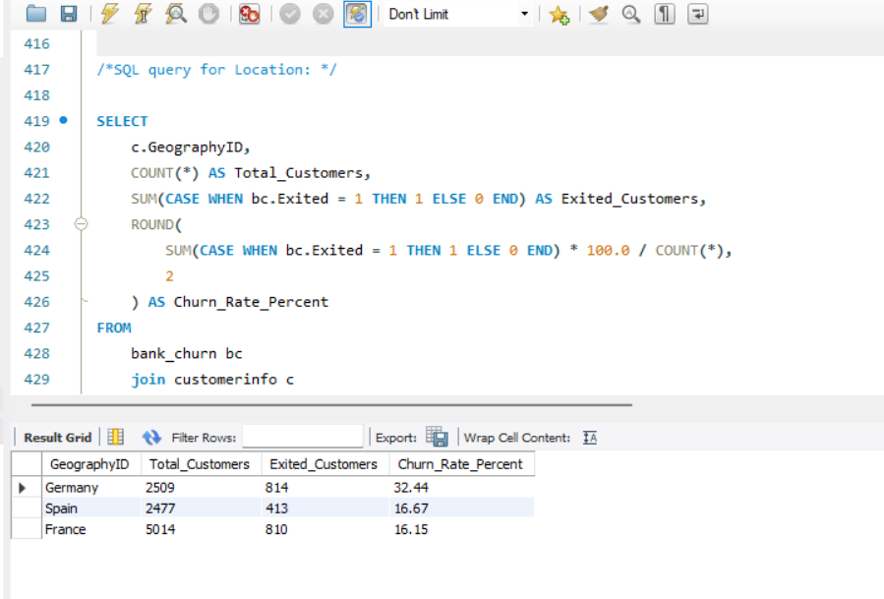

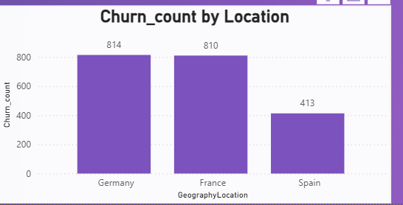
Insights:
- Germany and France shows the highest churn counts, almost double that of Spain. This indicates that churn risk is concentrated on Germany and France , while Spain customers appears more stable.
Recommendations:
- Conduct deeper analysis in Germany and France to identify dissatisfaction drivers.
- Strengthen customer engagement and retention programs in these two regions by giving personalized offers.

- Are 'Tenure', 'NumOfProducts', 'IsActiveMember', and 'EstimatedSalary' important for predicting if a customer will leave the bank?
Yes, those variables are very important in predicting customer churn and her is why each one matters :
NumOfProducts : Having multiple products(Ex:savings,credit card,loan ) makes customers to “locked in “ with the bank, reducing the chance of churn. Fewer products often means weaker engagement.
Tenure: Customers who have with a bank in longer are usually less likely to leave , since they have already built trust and relationships.Shorter-tenure customers are more at risk of churn.
IsActiveMember: Active customers are less likely to exit .Inactivity is often signal of churn risk.
EstimatedSalary: This may not directly cause churn but it helps to identify customer segment .High-salary customers might have more banking options ,making them harder to retain unless given personalized offers.
Finally , 'Tenure', 'NumOfProducts', 'IsActiveMember', are important strong for predictors of churn and 'EstimatedSalary'is a weak predictor but useful for segmentation.
SQL Query to for number of products:
SELECT
NumOfProducts,
COUNT(*) AS Total_Customers,
SUM(CASE WHEN Exited = 1 THEN 1 ELSE 0 END) AS Exited_Customers,
ROUND(
SUM(CASE WHEN Exited = 1 THEN 1 ELSE 0 END) * 100.0 / COUNT(*),
2
) AS Churn_Rate_Percent
FROM
bank_churn
GROUP BY
NumOfProducts
ORDER BY
Churn_Rate_Percent DESC;




Insights:
- High risk customers with 3 or 4 products ,these are very unstable segments. Almost all multi product customers left.
- Moderate risk with 1 product .
- Low risk with 2 products , this is the most stable and loyal segment.
Recommendations:
- Focus on customers with 3-4 products , because these customers should be the most engaged but instead show extreme dissatisfaction .
Action: Run exit surveys , check complaints , check whether these products overlap or confuse customers.
- Protect the 2-product segment , because they are the most satisfied group.

SQL query for tenure:

SELECT
Tenure,
COUNT(*) AS Total_Customers,
SUM(CASE WHEN Exited = 1 THEN 1 ELSE 0 END) AS Exited_Customers,
ROUND(
SUM(CASE WHEN Exited = 1 THEN 1 ELSE 0 END) * 100.0 / COUNT(*),
2
) AS Churn_Rate_Percent
FROM
bank_churn
GROUP BY
Tenure
ORDER BY
Churn_Rate_Percent DESC;



Insights:
- Churn peaks at 4-5 years , showing mid-term disengagement.
- Churn is lowest after 7 years tenure , indicating stronger loyalty among long-term customers.
- Customers in the early tenure also churn less than 4-5 years segment.
Recommendations:
- Focus on proactive engagement at 3-4 years to prevent midterm attrition.
- Strengthen long term retention programs for customers beyond 5 years , rewarding for maintaining their low churn levels.
- Conduct feedback surveys around year 4 to uncover dissatisfaction drivers leading to churn.

SQL query for Estimated salary:

SELECT
CASE
WHEN ci.EstimatedSalary < 50000 THEN 'Under 50K'
WHEN ci.EstimatedSalary BETWEEN 50000 AND 100000 THEN '50K - 100K'
WHEN ci.EstimatedSalary BETWEEN 100001 AND 150000 THEN '100K - 150K'
ELSE '150K+'
END AS SalaryRange,
COUNT(bc.CustomerId) AS TotalCustomers,
SUM(bc.Exited) AS ExitedCustomers,
ROUND(SUM(bc.Exited) * 100.0 / COUNT(bc.CustomerId), 2) AS ChurnRate
FROM
bank_churn bc
JOIN
customerinfo ci ON bc.CustomerId = ci.CustomerId
GROUP BY
SalaryRange
ORDER BY
ChurnRate DESC;

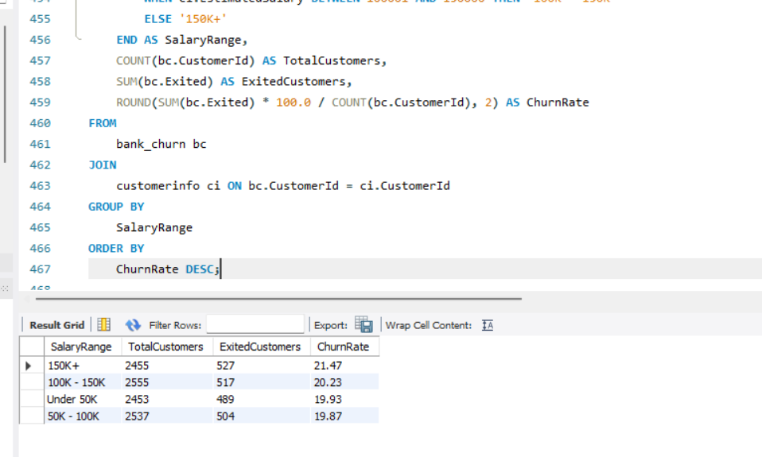

Insights:
- Churn is highest among high-income customers , followed closely by the 100K-150K.
- Middle income groups churn at slightly lower levels.
- Lowest churn count is in the under 50K group, showing relatively strong retention.
Recommendations:
- Focus retentions efforts on high income customers, as they represent the high churn segment, offers premium services, wealth management.
- Protect mid income customers by ensuring competitive product offerings and avoid neglect.

- Utilize SQL queries to segment customers based on demographics and account details.
To effectively segment customers based on their demographics and account details, I followed a structured approach using SQL queries on two datasets: customer_info and bank_churn. My objective was to derive meaningful customer segments that could help the bank improve targeting, retention, and overall customer satisfaction.

Approach:
I created customer segments using SQL CASE statements and GROUP BY clauses based on:
- Age Groups: e.g., Under 30, 30–50, and Over 50.
- Gender and Churn Status: to analyse churn trends across genders.
- Geography and Activity: to understand regional engagement and loyalty.
- Credit Score Tiers: to classify customers into Low, Medium, and High creditworthiness.
These segments helped identify patterns like which age group or region had the highest churn or which customers were inactive but had high balances.
SQL query for Segment by Age Group
SELECT
CASE
WHEN Age BETWEEN 18 AND 25 THEN '18-25'
WHEN Age BETWEEN 26 AND 35 THEN '26-35'
WHEN Age BETWEEN 36 AND 45 THEN '36-45'
WHEN Age BETWEEN 46 AND 55 THEN '46-55'
WHEN Age BETWEEN 56 AND 65 THEN '56-65'
ELSE '65+'
END AS Age_Group,
COUNT(*) AS Customer_Count
FROM customerinfo
GROUP BY
CASE
WHEN Age BETWEEN 18 AND 25 THEN '18-25'
WHEN Age BETWEEN 26 AND 35 THEN '26-35'
WHEN Age BETWEEN 36 AND 45 THEN '36-45'
WHEN Age BETWEEN 46 AND 55 THEN '46-55'
WHEN Age BETWEEN 56 AND 65 THEN '56-65'
ELSE '65+'
END
ORDER BY Customer_Count DESC;
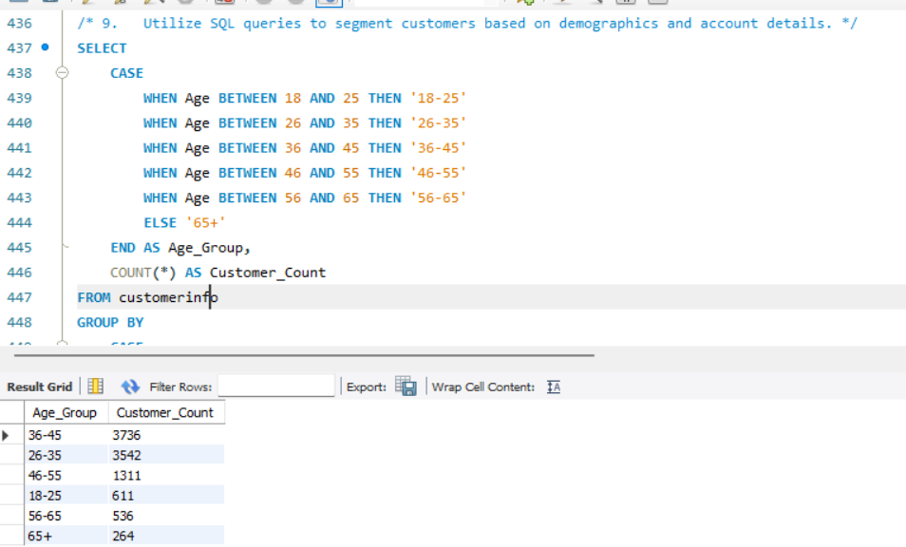

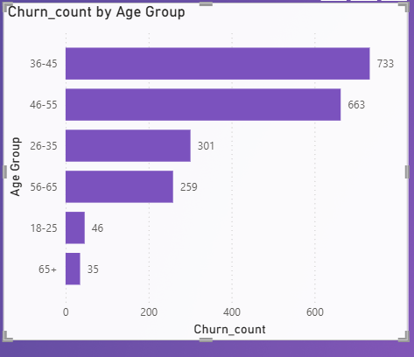
Insights:
- The 36-45 and 26-35 groups form the largest customer base, making up the majority of the portfolio.
- 46-35 group customers are mid-sized segment , while younger and older groups are relatively small.
- 65+ group is the smallest , suggesting limited penetration among senior customers.
Recommendations:
- Prioritize retention in 26-45 age group since they make all the bulk of customers
- Targeted engagement for 46-55 with wealth building and retirement planning products to maintain loyalty.
- Expand services for seniors through retirement -friendly products .

SQL query to Segment by Gender and Churn Status

SELECT
ci.GenderID,
bc.Exited,
COUNT(*) AS Customer_Count
FROM customerinfo ci
JOIN bank_churn bc ON ci.CustomerId = bc.CustomerId
GROUP BY GenderID, bc.Exited;
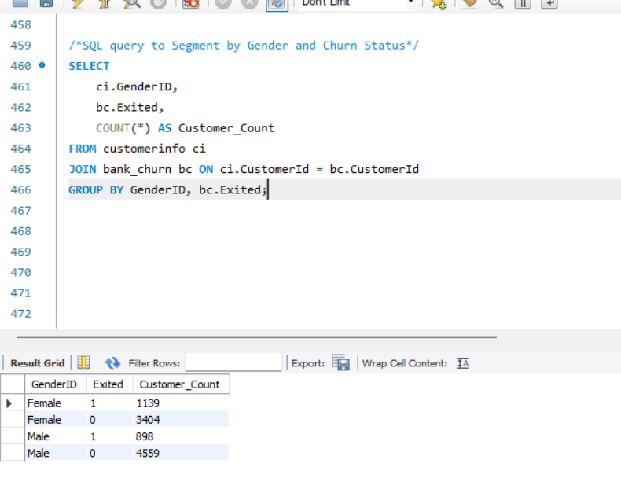

Insights:
- Female customers had a slightly high churn rate compared to male customers.
Recommendations:
- Investigate female customer experience , through surveys .
- Continue reinforcing loyalty among male customers.

SQL Query to Segment by Geography and Account Activity

SELECT ci.GeographyID,
bc.Exited,
COUNT(*) AS Customer_Count
FROM customerinfo ci
JOIN bank_churn bc ON ci.CustomerId = bc.CustomerId
GROUP BY ci.GeographyID, bc.Exited;
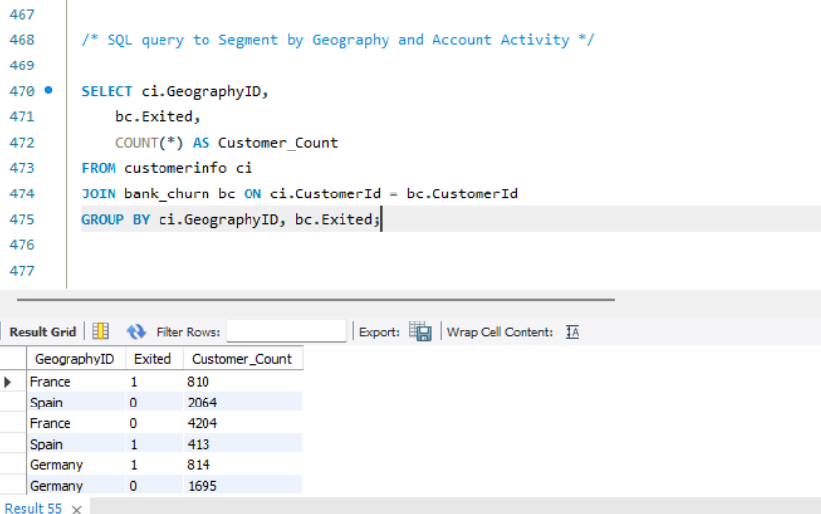

Insights:
- France has the highest customer base .
- Germany has fewer customers overall but very high churn rate , worst performing region.
- Spain has moderate churn.
Recommendations:
- Germany requires immediate attention , investigate dissatisfaction drivers. Launch retention programs , localised offers.
- For France and Spain , churn rates are relatively low , but monitor trend closely to prevent escalation.

SQL Query to Segment by Credit Score Range
SELECT
CASE
WHEN CreditScore < 600 THEN 'Low'
WHEN CreditScore BETWEEN 600 AND 750 THEN 'Medium'
ELSE 'High'
END AS CreditScore_Segment,
COUNT(*) AS Customer_Count
FROM bank_churn
GROUP BY CreditScore_Segment;
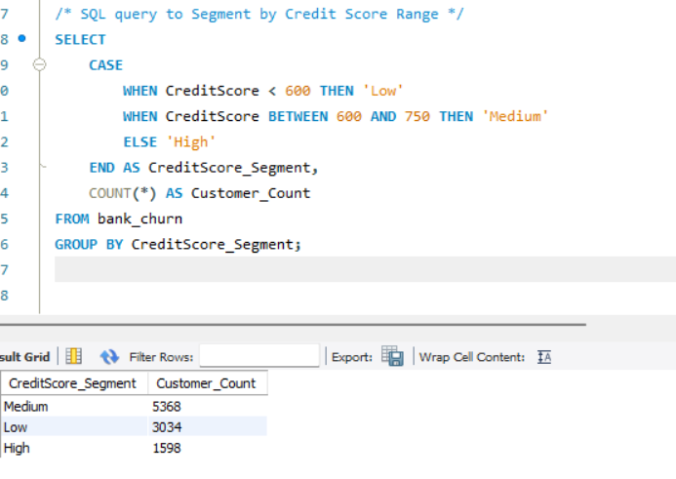

Insights:
- Majority of the customers fall into the medium score range.
- A significant portion are in the low credit score category , higher risk of churn and defaults.
- Only 16% are in high credit score group , representing small but more stable and loyal.
Recommendations:
- Focus on retaining Medium-score customers by offering tailored financial products .
- For High score customers, provide exclusive perks and premium services to maintain loyalty and prevent competitors from attracting this profitable segment.

- How can we create a conditional formatting setup to visually highlight customers at risk of churn and to evaluate the impact of credit card rewards on customer retention?
To Create a Churn Risk Indicator (DAX)
Created a new column in Power BI to classify customers as "High Risk", "Medium Risk", or "Low Risk" based on factors like:
- Exited = 0
- CreditScore < 600
- Balance = 0
- NumOfProducts = 1
- HasCrCard = 0
Dax Formula:
ChurnRisk =
SWITCH(
TRUE(),
Bank_Churn[Exited] = 0&&bank_churn[CreditScore]<600&&bank_churn[Balance] = 0, "High Risk",
Bank_Churn[Exited] = 0&&bank_churn[NumOfProducts] = 1, "Medium Risk",
"Low Risk" )
2. Applied Conditional Formatting to a Table
- Added a table visual with fields like CustomerId, Surname, ChurnRisk, HasCrCard, Exited.
- Rules applied:
Red for "High Risk"
Orange for "Medium Risk"
Green for "Low Risk"

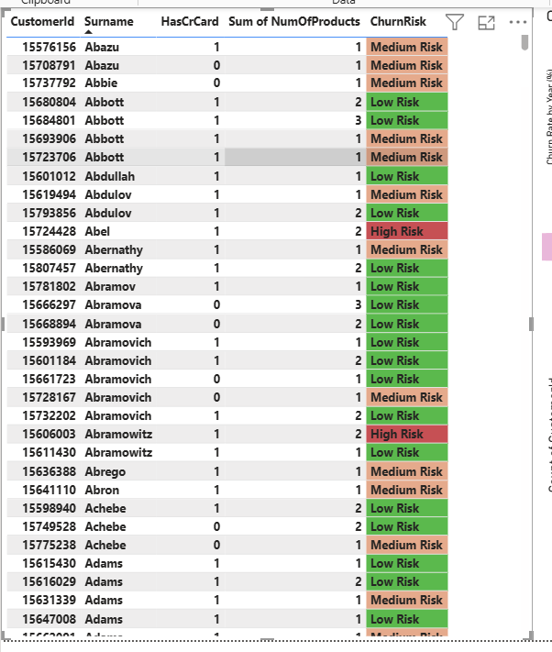
Insights:
- Conditional formatting helped visually distinguish high risk customers , primarily those who are inactive ,have low credit score ,no balance and only one product.
- These customers are likely disengaged and may require immediate retention actions.
Recommendations:
- Prioritize retention campaigns for high-risk customers with personalised offers .
- Use targeted communication to educate and re-engage low credit score customers.
- What is the current churn rate per year and overall as well in the bank? Can you suggest some insights to the bank about which kind of customers are more likely to churn and what different strategies can be used to decrease the churn rate?
To calculate current churn rate per year , I have used the following DAX formulas:
Overall Churn Rate (%) =
DIVIDE(
COUNTROWS(FILTER(bank_churn, bank_churn[Exited] = 1)),
COUNTROWS(bank_churn)
) * 100
AND
Churn Rate by Year (%) =
VAR TotalCustomers = COUNTROWS(customer_info)
VAR Churned =
CALCULATE(
COUNTROWS(bank_churn),
bank_churn[Exited] = 1
)
RETURN DIVIDE(Churned, TotalCustomers) * 100
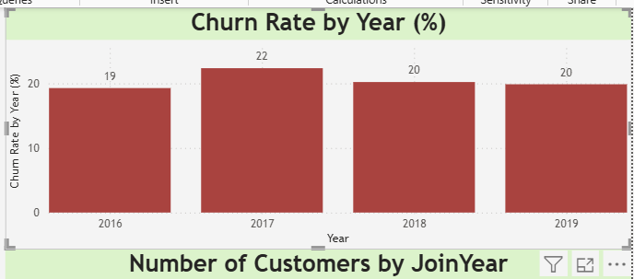

Insights:
- The churn rate has remained relatively stable between 19-22% over the years.
- 2017 saw the highest churn , after which it slightly reduced to 20% in 2018 and 2019
Recommendations:
- Deep-dive into 2017 churn spike , identify policy changes , competitor moves.
- Introduce proactive retention program .
- Monitor churn drivers continuously.
- Create a dashboard incorporating all the KPIs and visualization-related metrics. Use a slicer in order to assist in selection in the dashboard.
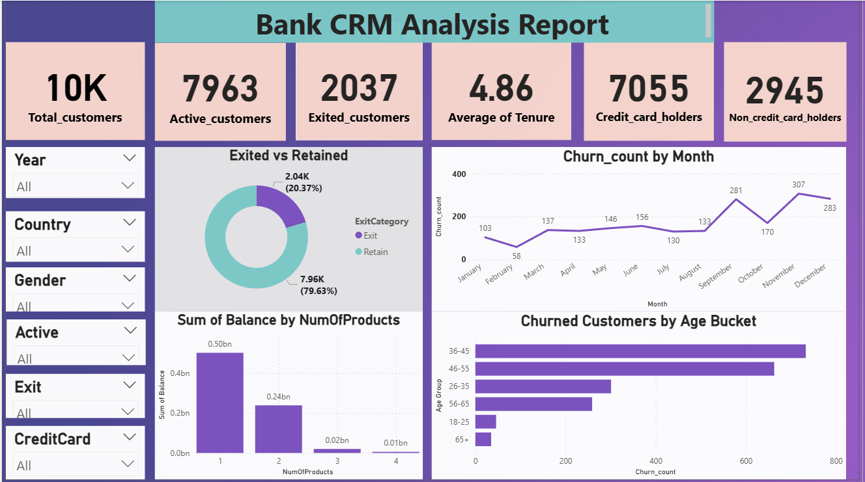
- How would you approach this problem, if the objective and subjective questions weren't given?
If no predefined questions were provided , here is how I would approach the churn analysis problem step by step.
- Define the objective, gain a clear understanding of customer churn patterns and identify actionable opportunities to improve retention and engagement.
- Data exploration and Preparation , clean and prepare data for analysis. Explore key attributes such as age, credit score , account balance ,tenure , product usage and activity status.
- Establish Key Metrics :
- Churn performance : Overall churn rate and yearly churn trends.
- Product adoption : Usage of credit cards and multiple products.
- Engagement : Inactivity levels and tenure-based churn segmentation.
- Build visual insights (Power Bi / Excel Dashboard)
Churn trends by join year and region.
Relationships between credit card ownership and churn.
Risk heatmaps to highlight high-risk customer segments.
- Identify churn drivers
Determine which customer characteristics are associated with churn.
- Develop Targeted retention strategies
Provide personalised offers and engagement campaigns for high-risk customers.
Launch product bundles and loyalty programs to increase stickiness.
Enhance onboarding experience to reduce early churn among new customers.

- In the “Bank_Churn” table how can you modify the name of the “HasCrCard” column to “Has_creditcard”?
To rename the column , SQL query is
ALTER TABLE Bank_Churn
RENAME COLUMN HasCrCard TO Has_creditcard;

